**ASSIGNMENT – 3 & 4**

**Question – 1**

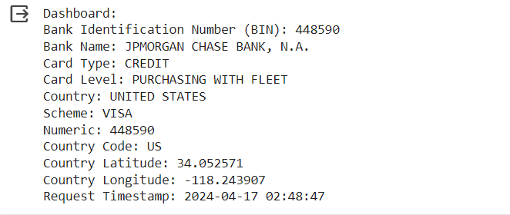

This dashboard gives a thorough overview of the BIN information, including bank details, card information, and country-specific data. Depending on your needs, you may improve the dashboard by including more important facts or arranging the output in a more visually attractive manner.